CS 471/571 Assignment #5

Full Name: Milson Munakami

Turn in your work as a single file via Blackboard. Make sure your full name is included in the file name. Handwritten answers will not be accepted.

- Cohesion, coupling, and reusability (Chapters 7 & 8).

  - What is the influence of cohesion on reusability? (10 points)
Answer:
Reusability is the extent to which a software component is able to be reused. Cohesion is a measure of degree of how strongly a class focuses on its responsibilities. In object-oriented design, it is desirable that a software component should have High cohesion to be more reusable this means that a class is designed to carry on a specific and precise task. Using high cohesion, methods are easier to understand and maintain, as they perform a single task and it will promotes encapsulation. Hence, using appropriate design and coding standards along with components having High cohesion make it more reusable.

  - What is the influence of coupling on reusability? (10 points)
Answer:
It is desirable that reusable components should have loose coupling such that the dependence with other components should be less. Higher combining increases interclass dependencies, making the rule less modular and less ideal for reuse. The more hyperlinks and interactions between classes; the more complicated the rule and the more difficult it is to check and maintain. Hence, loose coupling will promotes higher reusability on software components.

- (Refer to slides 32 and 33 of Chapter 12 The Design Workflow) Modify both the traffic light state machine diagram and the textual traffic light model so that they represent the state transitions of real traffic lights in Boise. Consider only one-direction without left/right turn signals. (30 points)
Answer:
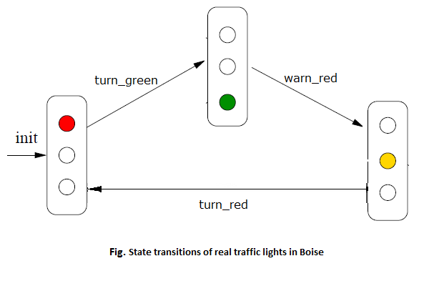
Traffic Light Model in Boise:

local
red : Bool := true,
yellow : Bool := false,
green : Bool := false
begin
[ turn_green ]
red ∧ ∼yellow ∧ ∼green → red′ = false ∧ green′ = true
||
[ warn_red ]
∼red ∧ ∼yellow ∧ green → yellow′ = true ∧ green′ = false
||
[ turn_red ]
∼red ∧ yellow ∧ ∼green → red′ = true ∧ yellow′ = false
end

- Code Review and Improvement. Discuss three issues of the MSG source code according to object-oriented design principles and how each of these issues can be addressed. (Optional: you may submit the source code of your improved version) (50 points)
Answer:
Without graphical interface (GUI) it is harder for users to interact with the application.
The UserInterface class has following methods which are not well formed according to the object-oriented design principles.
clearScreen () : just making loop through 26 counter to print new line
pressEnter() : the application doesn’t start unless user click on enter or any keyboard buttons.
displayMainMenu() : it has more than one responsibility or have more than one specific and precise tasks i.e. displaying menu as well as do some task based on the user’s input choice. This type of loose cohesion is not desirable.

The MSGApplication class contains: setAnnualOperatingExpenses and updateAnnualOperatingExpenses () which are calling eachothers which violates the principle of Low coupling. High coupling makes modifying parts of the system difficult, e.g., modifying a component affects all the components to which the component is connected. Component directly modifies another’s data. various subcomponents interact eachother make it more complex and more hard to maintain and reuse.

setEstimatedFundsForWeek() set the estimatedFundsForWeek and also do the Report printing job.

Investment class
totalWeeklyReturnOnInvestment

EstimateFundsForWeek class:

AssetManager class contains manageInvestment() method which has more than one task to do like print the print ();, save it and even show the menu for user interaction and get input.
manageMortgage ()() class has the same issue like doing multiple how strongly a

class focuses on its responsibilities is called cohesion.

Asset class has delete() method which is based on line of characters

effect of cohesion on maintenance
effect of coupling on maintenance

Reusability and Portability
Documentation
Quality Assurance

